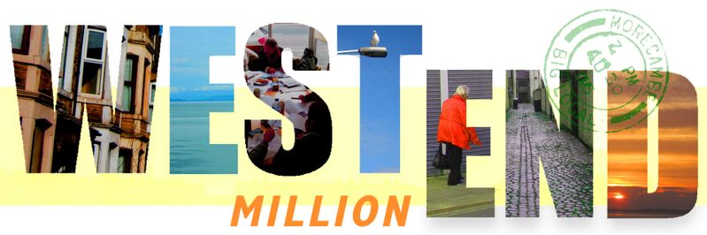
West End Million Community Chest Application Form

Project Theme
What theme does your project fit into? (please tick)
Health & Well-Being
Place
Community
Enterprise & Economy

What is your project called?

This form is designed to be used by community organisations. If you don’t yet have an organisation supporting you to develop your idea please fill in our Big Ideas Form, available on our website at www.westendmillion.co.uk/grants/
Are you applying as an organisation? | YES/NO

Applicant Details
Name of your organisation:
Name of contact person:
Contact address:
Postcode:
Telephone Number:
Contact email:

These next questions help us understand what type of organisation you are. There are no right or wrong answers but, depending on what you want to do with your community chest grant, it might be important that you have some of these things in place. Or they might not be relevant to your activity. Please be honest and if we have any concerns we will discuss these with you.

Is your organisation run by volunteers? | YES/NO
Does it have a formal constitution and a management committee? | YES/NO
Is your organisation a registered charity? | YES/NO
If yes, what is your charity number?
Is your group part of a regional or national organisation? | YES/NO
Does your organisation have shareholders? | YES/NO
If yes, do they receive dividends? | YES/NO
Do you have audited accounts for your last financial year? | YES/NO
Do you have an Equality Policy that sets out how your include people? | YES/NO
Do your staff and volunteers have clearance from the Disclosure Barring Service? | YES/NO
Do you have safeguarding policies in place? | YES/NO
Do you have Public and Employers Liability Insurance? | YES/NO
Do you have a bank account in the name of your organisation with more than one signatory? | YES/NO

About Your Organisation
Tell us about your organisation and what you do. How long have you existed? Where are you based? How many members and users do you have? Who is your group for and how do you support them?

About Your Project
What do you need funding for? How will your project work? How will you get local people involved?
Which other local organisations are you working with on this project?
When will your project start?
When do you expect it to finish?
How do you know that your project is needed? Please tell us about any consultation you have carried out or other evidence you have that there is a demand for your project.

Project Cost
What is the total cost of your project?
What is the amount you are requesting from the West End Million Community Chest?
What will you spend the grant on? Please breakdown the cost in to headings e.g. room hire, travel expenses, printing etc.
Item | Cost £
Total | £

Funding Continuity
If you have run this project before, who funded it then?
How will you fund your project after the West End Million Big Local grant has run out?

Project Aims
What will your project achieve? How many people will you support and what will change for them as a result? How will you know that this has happened?

Declaration
- I confirm that I am authorised to sign this application on behalf of my voluntary/ community group.
- The information provided is, to the best of my knowledge, true and accurate.
- Any grant awarded will only be used for the purposes stated in the application form unless amendments have agreed by West End Million in advance of spend.
- I agree to forward receipts to West End Million to show the money was spent on the items outlined in the application form. I understand that West End Million might ask to see the financial records of my organisation.
- I agree that my organisation will return any unspent grant that remains at the agreed end of the project.
- I agree that the support of West End Million will be acknowledged in any publicity material produced about the project.
- I will endeavour to provide a testimonial from at least one of the people attending/benefiting from the project so that West End Million can understand the impact the project has had for individuals.
- I agree to complete a feedback form and provide information about the project outcomes at the end of the project. I give consent for WEM to contact me for the purposes of collecting monitoring information and I understand that West End Million may use the information provided.
- I understand that the decision taken by the West End Million Grant Panel is final.

Name:
Position:
Signature:
Date:

Please tell us how you heard about the WEM Community Chest awards:
WEM Website
Social Media
More Together magazine
Conversation with WEM representative
Word of Mouth
Other ___________________________________________________________
Please return this form by e-mail if you can to admin@westendmillion.co.uk.
If you don’t have access to e-mail, please post to us c/o Yak Patel, Lancaster District CVS, The Cornerstone, Sulyard Street, Lancaster LA1 1PX

