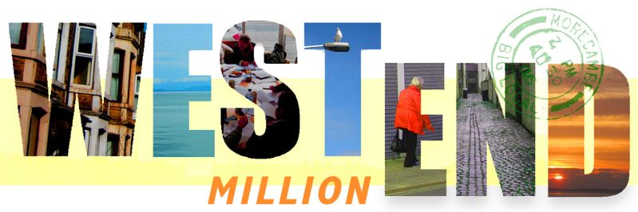

MY WEST END IDEA
“We know that there are lots of local people who have their own great ideas for making life better for residents in the West End Million area but don’t quite know how to make it happen. The West End Ideas fund is a chance for individuals or a group of residents to tell us what they’d like to make happen in the West End. You don’t have to have everything worked out but if the idea sounds good we might be able to make some funding available to develop it or put you in touch with an organisation who could help you try and make the idea happen”.

Please tell us your name:
Please tell us your address:
Please tell us your phone number:
Please tell us your email address:

Please tell us your WEST END IDEA:

Thank you. If you have any questions about the West End Ideas fund or need help in completing the form then please contact us at admin@westendmillion.co.uk or write to us via Yak Patel, Lancaster District CVS, The Cornerhouse, Sulyard Street, Lancaster LA1 1PX.

